- Sarah has $20 more than Frank, but $40 less than Bruce. If Bruce has $10 more than twice the amount that Frank has, find how much money each person has.

- Find the value of $x$ in the following magic square. The rule for any magic square is that the sum of each row, column and diagonal are equivalent

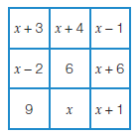

- Three times Theo’s age a year ago, is the same as double his age in five years’ time. Find Theo’s age now.

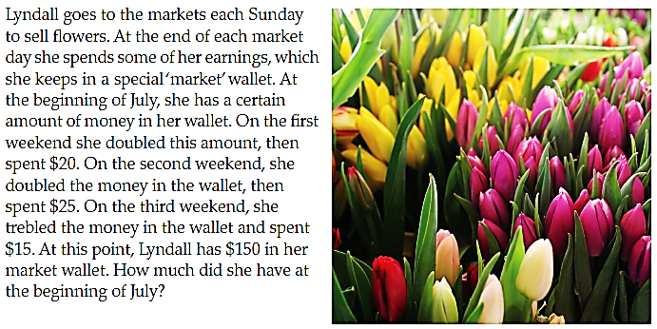



- Rectangle A and B have the same are. Find $x$.
